Mary Fesak
Dr. Mackintosh
HIST 319
December 1, 2014
Dolley Madison, Interior Design, and Political Space

The President’s House was a physically and socially undefined space when the Madisons moved in. The unfinished interiors provided Dolley Madison with a blank canvas to create a space that both represented the nation and offered a place for bipartisanship. Dolley Madison and architect Benjamin Latrobe used elegant interior decorations and Grecian furniture to set the stage for James and Dolley Madison’s socio-political performances. While the form of the space followed aristocratic styles, the Madison’s use of the space reflected the democratic principles of the early American republic. Dolley Madison’s gendered use of power as a hostess enabled her husband to quietly politick.
The interior of the White House was undeveloped when the Madisons moved in. President Thomas Jefferson had focused his efforts on improving the exterior of the building and left most of the interior unfinished. James Madison authorized his wife and Latrobe to manage the transformation of the space into a social arena for the president to entertain. Although Latrobe was formally the designer, Dolley heavily influenced his work. She had to approve of his designs, often critiquing them to fit her own aesthetics before he sent final plans to artisans and craftspeople. She also sent him shopping lists for furnishings and decorative arts, inspecting the pieces before they were installed. Dolley and Latrobe designed three social rooms: Dolley Madison’s Parlor, the State Dining Room, and the Drawing Room, or the present day Oval Room. Dolley heavily favored French styles, as evidenced by her fashionable attire. Because of the lack of democracy in Napoleonic France, Latrobe believed that French interior design did not symbolically reflect the political values of the early American republic. Despite American Anglophobia, he persuaded Dolley to use British Grecian furniture because it evoked the democratic paradigms of Ancient Greece. Dolley’s and Latrobe’s use of Grecian furniture connected the President’s House to the republican values of classical antiquity idealized by the Democratic-Republicans.
Latrobe’s masterpiece was the Oval Drawing Room which he sought to tie into the early classical revival style of the building. He made few physical changes to the room itself including refreshing the plaster, altering some of the woodwork, and installing an exquisite marble mantelpiece. He had the walls papered and the decorative woodwork painted white with shadowing to suggest stone. He employed English decorator George Bridgeport to paint the ceiling. At Dolley’s insistence, Latrobe bought red silk velvet curtains to drape the room’s eighteen-foot-tall windows, alcoves, and exterior double doors. He also purchased over 169 yards of Brussels carpet to cover the floor. The space resulting from these treatments was grand, but not so excessively lavish to evoke the image of European courts.
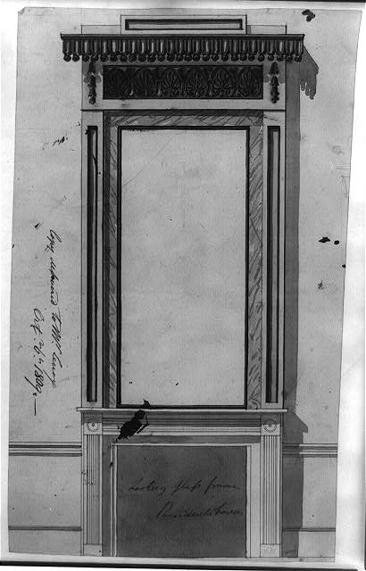
Furthermore, Latrobe designed the furnishings of the Drawing Room to connect the treatments to the democratic ideals of the early American republic. He designed a frame for the overmantel mirror. The mirror frame featured the Grecian motifs of laurel and anthemia, symbolizing America’s democratic heritage. The frame also featured a lambrequin valance with gilded wooden balls which was likely repeated above the windows, mirrored alcoves, and doors to make the room appear as if it had windows on all of the walls. The room’s symmetry reflected the Classical design aesthetic, implying a connection to ancient Greece and Rome.
Figure 1 shows Latrobe's design for the overmantel mirror frame. Note the Grecian motifs beneath the lambrequin valance. (Courtesy of the Library of Congress)
Latrobe also designed the seating for the Drawing Room. John and Hugh Finlay of Baltimore built and painted the furniture. They made thirty-six chairs inspired by Greek klismos chairs. They also produced two sofas and four settees with reverse tapered Doric column legs, a reference to Roman lectus couches. The cushions of the seating matched the curtains, visually tying the room together. The paintings on the furniture predominantly featured Grecian motifs such as laurel leaves, Greek stars, and anthemia. Latrobe also had Pierre Charles L’Enfant’s shield motif from Federal Hall painted on the sofas. Latrobe’s combination of Classical furniture styles, Grecian motifs, and the United States arms created a powerful image of America’s symbolic inheritance of Greek and Roman Republican democracy.
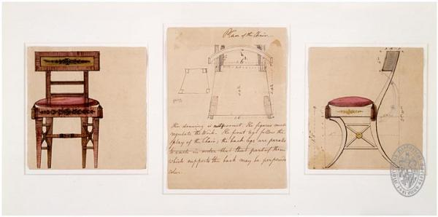
Figure 2 shows the Greek klismos-inspired chairs designed by Latrobe. (Courtesy of the Maryland Historical Society)

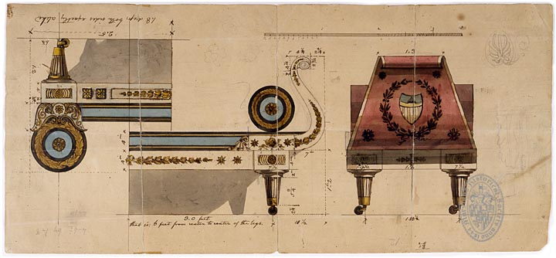
Figure 3 shows Latrobe's designs for the settees and the sofas. The settee is upside down. (Courtesy of the Maryland Historical Society)
Dolley had a more direct impact on the design of her Parlor. Dolley and Latrobe decorated the room in the Sheraton style, a fashionable Grecian aesthetic in contemporary Britain. Draperies made from sunflower yellow damask framed the windows. Valances made from the damask continued around the room, forming a drapery cornice. The fireboard in front of the marble mantel featured a rising sun made of matching fabric. The furniture was also upholstered in yellow satin fabric. The Parlor also contained several pier tables, card tables, a pianoforte, and a guitar purchased on Dolley’s orders. The room’s high style combined with the presence of musical instruments suggested America’s ability to achieve sophistication and elegance equal to European nations. However, the Grecian style paired with the rising sun motif, a powerful symbol of America’s new nationhood, served as a powerful symbol of the country’s republican values.
The State Dining Room received the least amount of redecoration by Dolley and Latrobe. Latrobe furnished the room with pieces from both of Jefferson’s dining rooms. Latrobe’s most significant purchase was a new ingrain carpet. The biggest problem was deciding the location of Gilbert Stuart’s portrait of George Washington. Latrobe sided with James Madison, who wanted the State Dining Room to be a presidential portrait gallery. Dolley had wanted the portrait to be hung in her Parlor, but she conceded. The presence of the life-sized portrait of Washington symbolically tied the State Dining Room into the suite by drawing from the first president’s legacy.
The rooms designed by Dolley and Benjamin Latrobe provided the setting for the Wednesday-night “drawing rooms” held by the Madisons. Guests usually entered the President’s house on the north side, proceeding through a columned hall to the Parlor where they were received by Dolley. Dolley often dressed in buff, yellow, or red to compliment the room. The Parlor opened into the Drawing Room as did the State Dining Room. Guests gathered in the Drawing Room to socialize. The Madisons laid food out on the State Dining Room table and waiters served beverages. On warm nights, the Madisons opened the doors and windows in the Drawing Room, allowing guests to access the south portico. During the winter, the Madisons closed the Parlor and heated the Drawing Room and State Dining Room with fires as well as an innovative central heating system installed by Latrobe. Similar to the French salon, the resulting gathering was significantly more dynamic than the formal dinners of past presidents. The three social rooms interconnected by double doors plus the moveable seating allowed for the flow of guests throughout the space, facilitating small group and one-on-one conversations that were so integral to politicking.
Dolley’s use of the salon-like space combined with her gendered use of power allowed the Madisons to stage their socio-political performances. In a compliment to American democratic ideals, Dolley essentially opened the space to the public for her Wednesday night events by placing advertisements in the newspapers. Anyone who had been introduced to the Madison’s could come, leading to a mixture of classes in attendance. Since all of the guests came of their own will, etiquette demanded that political rivals behave. As hostess, Dolley served as a mediator at the “drawing rooms” since proper women were seen as apolitical. Dolley performed her role as a hostess by balancing her warm personality with the dignity of her position. She dressed fashionably, but maintained her approachability and humanity by snuffing and rouging. With her feathered turbans, she had high visibility among her guests, causing her to be the central figure at the “drawing rooms.” Dolly’s performances as hostess enabled James Madison sit off to the side where the flexibility of the space allowed him to speak with a variety politicians in a more relaxed setting which was conducive to reaching political agreements that allowed him success as a president.
In conclusion, Dolley Madison and Benjamin Henry Latrobe successfully created a democratic socio-political space within the context of their aristocratic, classical interior designs. The accessibility of the space reinforced the ideals of democracy while the form of the suites allowed for a more informal, salon-like gathering. Dolley Madison’s performance as an “apolitical” hostess enabled James Madison to quietly politick and coalition build.

Bibliography
Allgor, Catherine. Dolley Madison: The Problem of National Unity. Lives of American Women. Edited by Carol Berkin. Boulder, CO: Westview, 2013.

-----. “Political Parties: First Ladies and Social Events in the Formation of the Federal Government.” In The Presidential Companion: Readings on the First Ladies. Edited by Robert P. Watson and Anthony J. Eksterowicz. University of South Carolina Press.

Gerson, Noel B. The Velvet Glove. Nashville: Thomas Nelson, 1975).

Kirtley, Alexandra Alevizatos. "Contriving the Madison's Drawing Room: Benjamin Henry Latrobe and the Furniture of John and Hugh Finlay." Magazine Antiques Magazine 176, no. 6 (December 2009): 56–63. http://ezproxy.umw.edu:2048/login?url=http://search.ebscohost.com/login.aspx?direct=true&db=ofm&AN=504356605&site=ehost-live (accessed November 30, 2014).

Klapthor, Margaret Brown. Benjamin Latrobe and Dolley Madison Decorate the White House, 1809-1811. Paper 49. Contributions from the Museum of History and Technology. Washington: Smithsonian, 1965.

McCoy, Drew R. The Elusive Republic: Political Economy in Jeffersonian America. Chapel Hill: University of North Carolina Press, 1980).

Scanlan, Laura Wolff. "Designs for a Republic." Humanities 27, no. 1 (January 2006): 10-11, http://ezproxy.umw.edu:2048/login?url=http://search.ebscohost.com/login.aspx?direct=true&db=ofm&AN=21334608&site=ehost-live (accessed November 30, 2014).

Seale, William. The President’s House. 2d ed. Vol. 1. Baltimore: Johns Hopkins University, 2008.

Zall, Paul M. Dolley Madison. Presidential Wives Series. Huntington, NY: Nova History Publications, 2001.

Margaret Brown Klapthor, Benjamin Latrobe and Dolley Madison Decorate the White House, 1809-1811, paper 49, Contributions from the Museum of History and Technology (Washington: Smithsonian, 1965), 156.
Noel B. Gerson, The Velvet Glove, (Nashville: Thomas Nelson, 1975), 192.
Klapthor, Benjamin Latrobe and Dolley Madison Decorate the White House, 155.
Alexandra Alevizatos Kirtley, "Contriving the Madison's Drawing Room: Benjamin Henry Latrobe and the Furniture of John and Hugh Finlay," Magazine Antiques 176, no. 6 (December 2009): 57, http://ezproxy.umw.edu:2048/login?url=http://search.ebscohost.com/login.aspx?direct=true&db=ofm&AN=504356605&site=ehost-live (accessed November 30, 2014).
William Seale, The President’s House, 2d ed., vol. 1 (Baltimore: Johns Hopkins University, 2008), 121.
Drew R.McCoy, The Elusive Republic: Political Economy in Jeffersonian America, (Chapel Hill: University of North Carolina Press, 1980), 8-10.
Seale, The President’s House, 121.
Seale, The President’s House, 123.
Catherine Allgor, Dolley Madison: The Problem of National Unity, Lives of American Women, ed. Carol Berkin (Boulder, CO: Westview, 2013), 74.
Klapthor, Benjamin Latrobe and Dolley Madison Decorate the White House, 162.
Seale, The President’s House, 123-124.
Laura Wolff Scanlan, "Designs for a Republic," Humanities 27, no. 1 (January 2006): 11, http://ezproxy.umw.edu:2048/login?url=http://search.ebscohost.com/login.aspx?direct=true&db=ofm&AN=21334608&site=ehost-live (accessed November 30, 2014).
Klapthor, Benjamin Latrobe and Dolley Madison Decorate the White House, 158.
Seale, The President’s House, 123.
Seale, The President’s House, 122.
Klapthor, Benjamin Latrobe and Dolley Madison Decorate the White House, 157.
Allgor, Dolley Madison: The Problem of National Unity, 75.
Klapthor, Benjamin Latrobe and Dolley Madison Decorate the White House, 157.
Seale, The President’s House, 122.
Allgor, Dolley Madison: The Problem of National Unity, 75.
Klapthor, Benjamin Latrobe and Dolley Madison Decorate the White House, 157.
Klapthor, Benjamin Latrobe and Dolley Madison Decorate the White House, 163.
Seale, The President’s House, 127.
Seale, The President’s House, 124.
Kirtley, "Contriving the Madison's Drawing Room: Benjamin Henry Latrobe and the Furniture of John and Hugh Finlay," 158.
Seale, The President’s House, 125.
Paul M. Zall, Dolley Madison, Presidential Wives Series, (Huntington, NY: Nova History Publications, 2001), 48-49.
Catharine Allgor, “Political Parties: First Ladies and Social Events in the Formation of the Federal Government,” in The Presidential Companion: Readings on the First Ladies, edited by Robert P. Watson and Anthony J. Eksterowicz, (University of South Carolina Press), 43.

